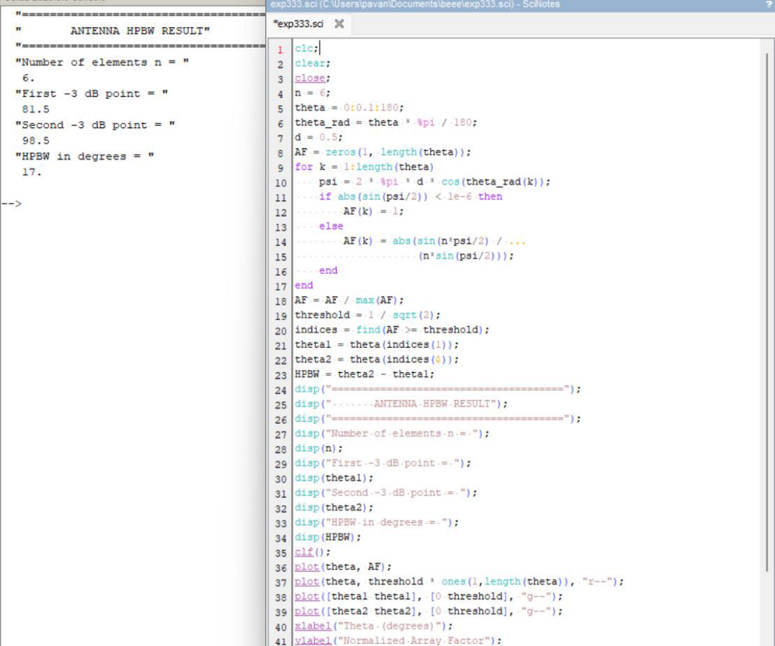

EXP:18
Exp No 18: Determination and plotting of Antenna Half power beamwidth.
Aim: To determine and plot Half Power Beamwidth (HPBW) and to determine the angular
width at -3 dB points

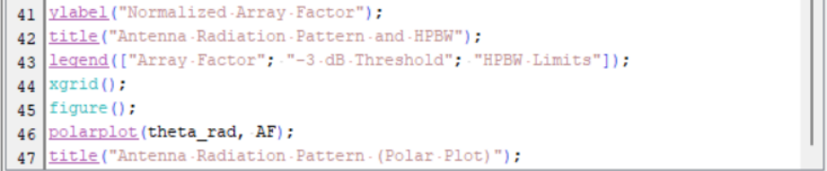
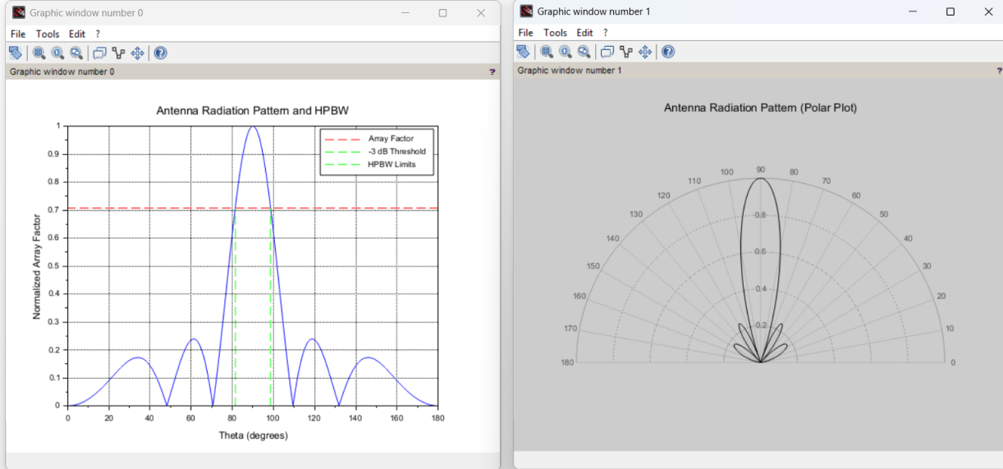

OUTPUT:

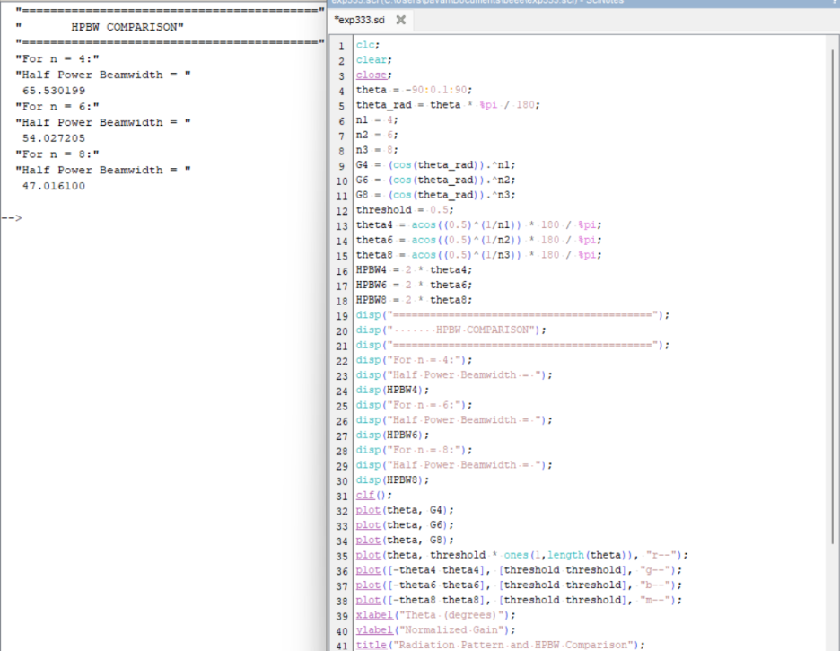
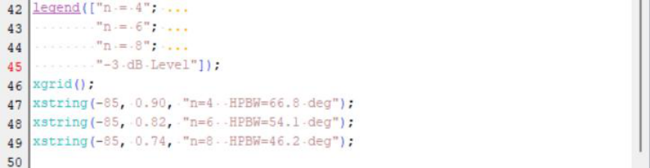

Case Study 1: Beamwidth Comparison for Different Directivity Factors

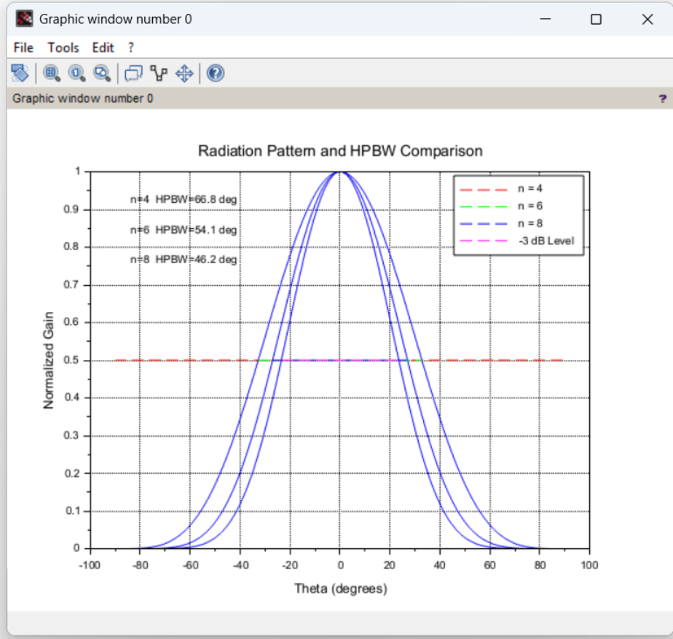

OUTPUT:

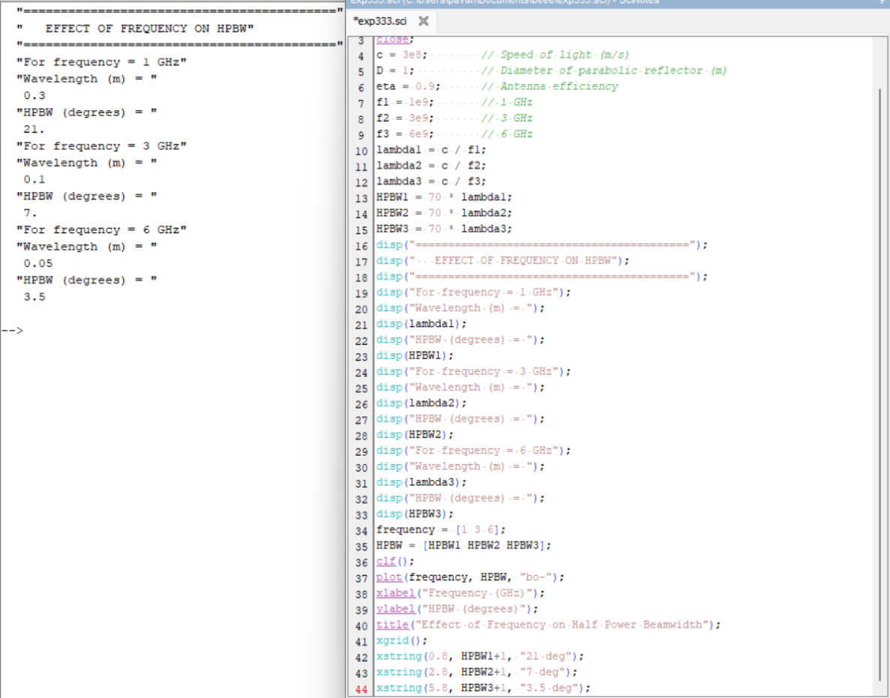

Case Study 2: Effect of Frequency on HPBW

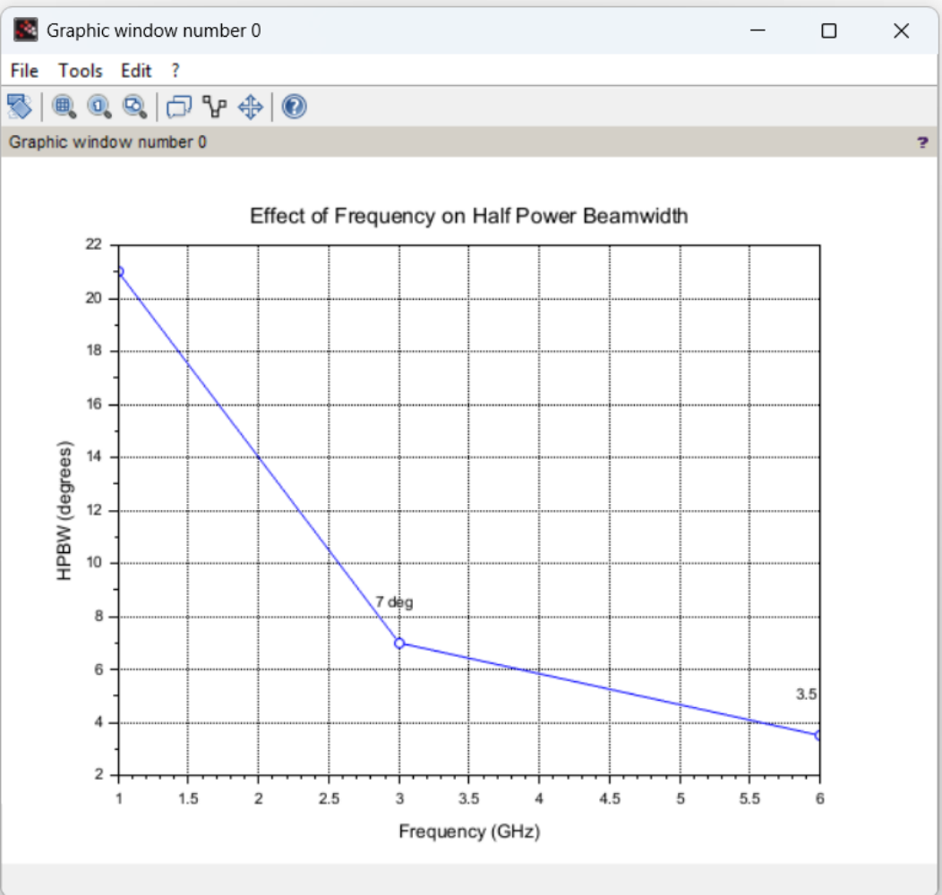

OUTPUT:

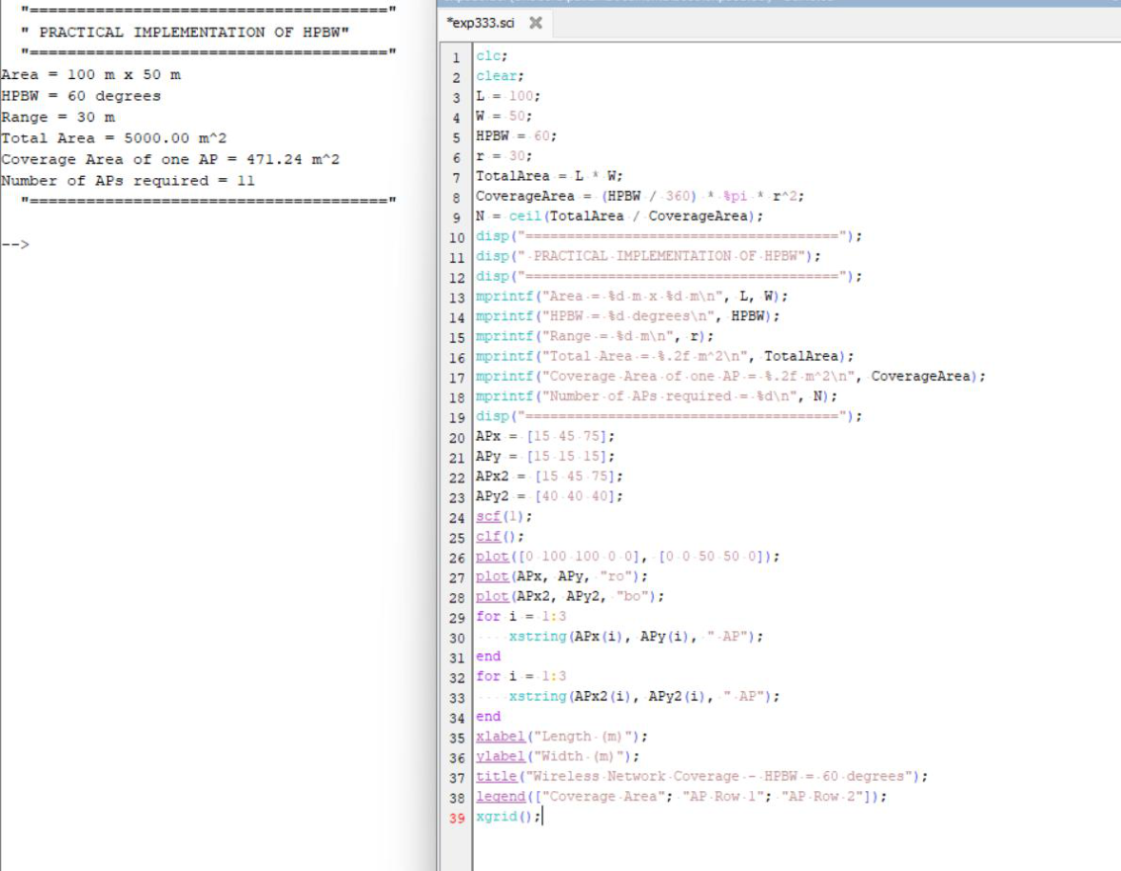

Case Study 3: Practical Implementation of HPBW in Wireless Networks

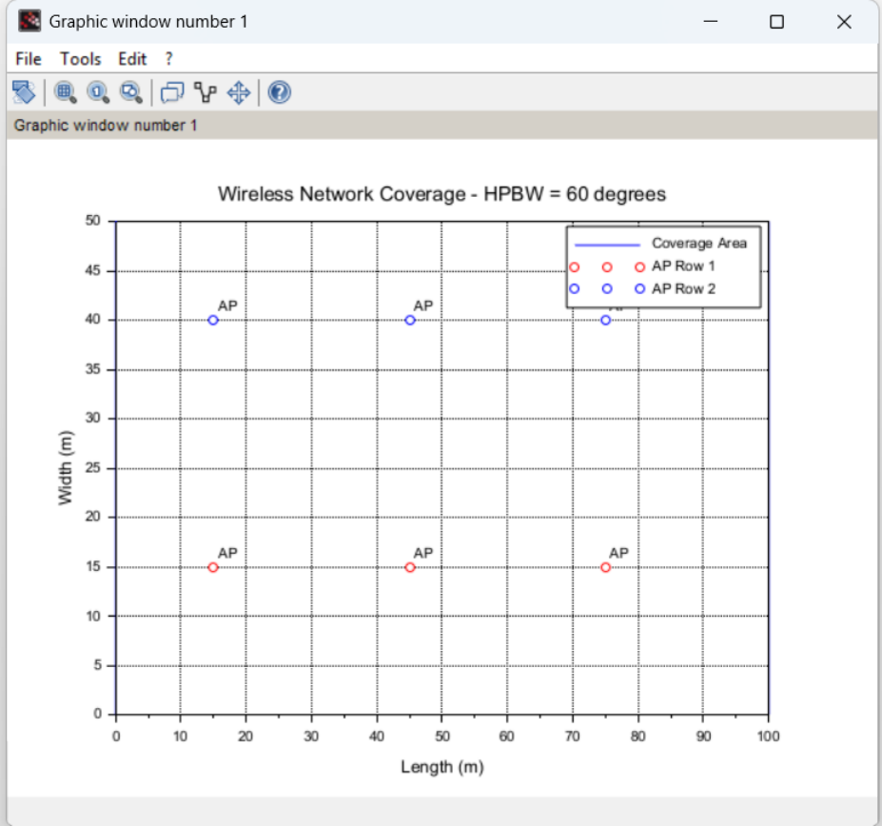

OUTPUT:

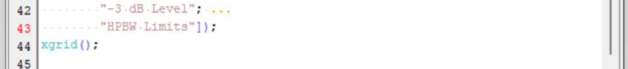
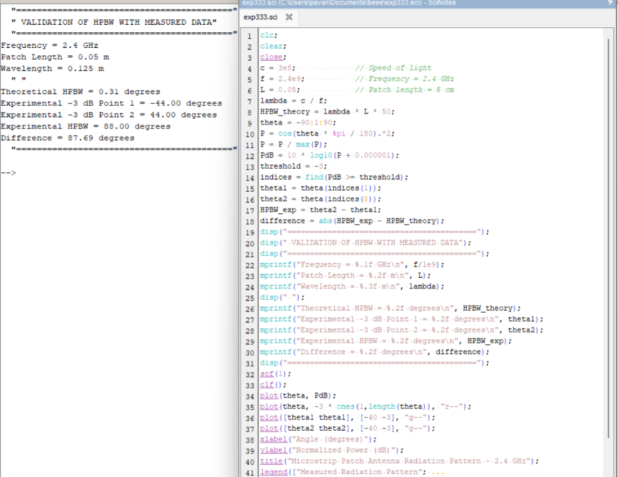

Case Study 4: Validation of HPBW with Measured Data

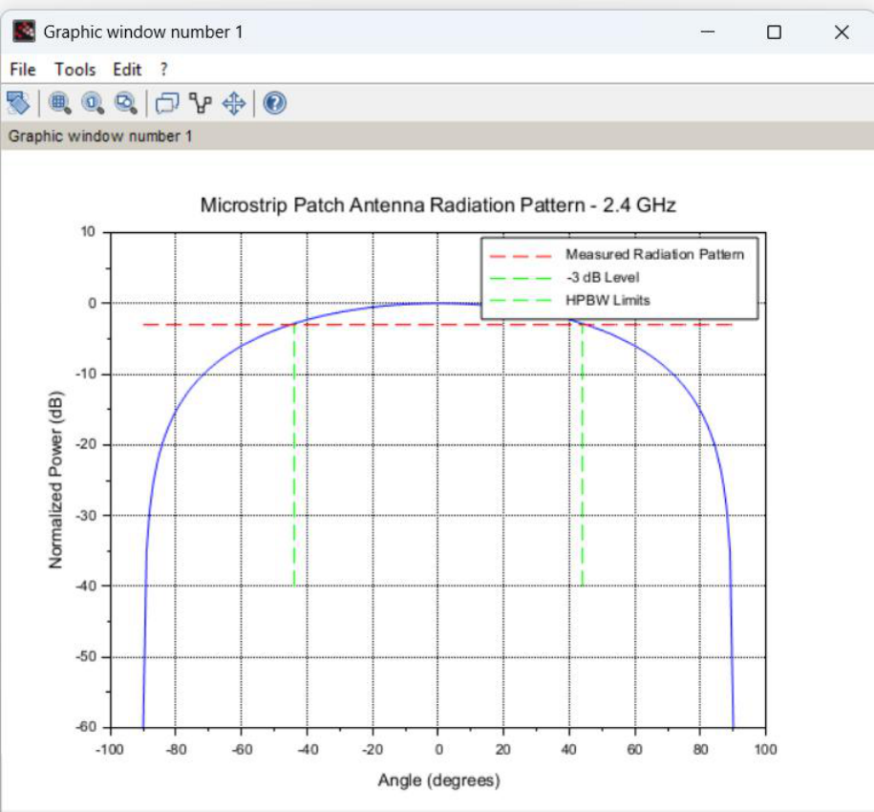

OUTPUT:

